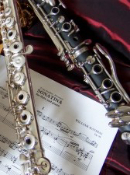
Loyola Blakefield Woodwind Music Recital Program
Monday, May 20, 2024; 7:00 pm
From the Studio of Noelle Presby

- Allegro by Devienne
Asher Freeman (‘29)-Flute (Duet)

- Hey, Soul Sister; Words and Music by Monahan, Lind & Bjorklund, arr. by Leonard
Clarinet Duet
Noel Francomano (‘29)-Clarinet

- Menuet by Handel
Asher Freeman (‘29)-Flute

- Gavotte and Hornpipe by Purcell
Noel Francomano (‘29)-Clarinet

- Allegretto by Devienne
- Andantino by Devienne
Eddie Birrane (‘27)-Flute (Duet)

- Allegro by Hohmann
Charlie Boutilier (‘27)-Clarinet (Duet)

- Slow Air by Finger
- A Trumpet March by Anonymous
Matthew Maraña (‘27)-Flute (Duet)

- Minuet; from L’Arlésienne Suite No. 2 by Bizet
Eddie Birrane (‘27)-Flute

- Concerto for Clarinet, K. 622 by Mozart
II. Adagio
Charlie Boutilier (‘27)-Clarinet

Noah Dion: Piano Accompanist
Mary Thielen: Band Director

