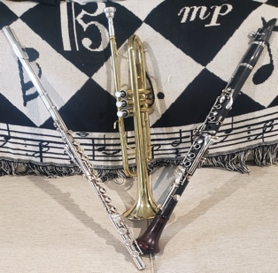
Instrumental Music Recital Program: Sunday, May 19, 2024, 4:30 pm
(From the studios of Noelle Presby and Alex Dzbinski)

- Moderato by Devienne
Carolina Razon-Fernandez (‘28)-Flute and Evelyn Crawley (‘30)-Flute

- Five Bagatelles by Finzi
III. Carol
IV. Forlana
Julianna Connolly (‘26)-Clarinet

- Giga by Handel
Evelyn Crawley (‘30)-Flute

- Serenade by Handel
Carolina Razon-Fernandez (‘28)-Flute

- Allegro Vivace; from Divertissement No. 2 by Ostransky
Aaliyah Perez (‘27)-Flute and Julianna Connolly (‘26)-Clarinet

- Romance by Brun
Liana Springer (‘26)-Flute

- Mira by Vandercook
Chloe Koger (‘24)-Trumpet

- Allemande by Handel
Liana Springer (‘26)-Flute and Sonya Heffernan (‘25)-Clarinet

- Sicilienne by Faure
Aaliyah Perez (‘27)-Flute

- Sonata No. 1 in F minor, Op. 120 by Brahms
I. Allegro appassionado
Sonya Heffernan (‘25)-Clarinet

Dorise Yousfi: Staff Accompanist
Sr. Patricia McCarron, SSND: Head of School
Alex Dzbinski: Department Chair of Performing Arts

